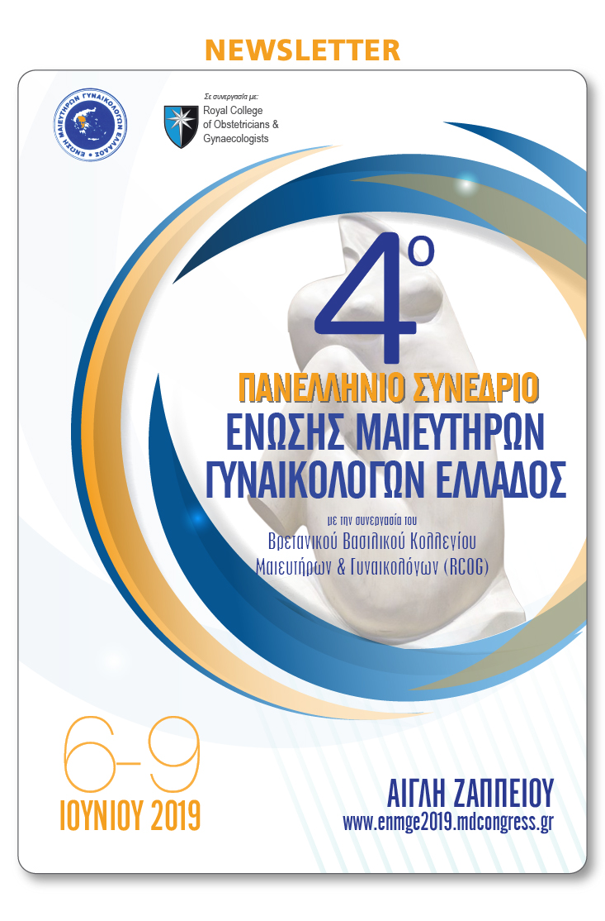

[](https://u7006186.ct.sendgrid.net/wf/click?upn=TX5UzgQbuzA6teklacwILQKQrZO0AqLvtf3qYrIEwaZE53S8mwrmn9Uwx2na1Oqpm-2FLyCCSPvnNYAsU6eQb241yPRrZ-2B1yDKHy3dU6HQzGg-3D_aszjhi05L32HwbyacBDOcC68BtqbqXiGF-2FrfiMIkj0O1QvVCWR29di3o8RmLnByd4QppdcrMJJwI1T6RuM2cddqsmfhJ9R8MB3l5UDh73S4o9SRSGUrQEweIG6KWTOuD11BPzqyGn2ikh5HadwMAKoRhC7tg4-2FuCbtqeNbl2OxO1a8Sge0wLfRasRNAL8k25cDTMVeVXUSzCESZt2ZCGmQ-3D-3D)



[](https://u7006186.ct.sendgrid.net/wf/click?upn=TX5UzgQbuzA6teklacwILQKQrZO0AqLvtf3qYrIEwaZE53S8mwrmn9Uwx2na1Oqp69bmjc1WnN4T5Ss7CPdA6cdsW12fI-2FWB-2B0ZThaSMQ2E-3D_aszjhi05L32HwbyacBDOcC68BtqbqXiGF-2FrfiMIkj0O1QvVCWR29di3o8RmLnByd-2B5KW-2F3NABxNVaUK19moioHhLMJlKEjsb2HNd43EIRo63uMb8m0LR63ChoqfKIHfENUhNyEdNm3bfMuyDjxSC3ja0J752U-2B-2FtPR6-2BYI4HBpYy12DJoFyRR39KRSJQFJ31QWVWlYXb04l3YYN5rRPnpw-3D-3D)

[](https://u7006186.ct.sendgrid.net/wf/click?upn=TX5UzgQbuzA6teklacwILQKQrZO0AqLvtf3qYrIEwaZE53S8mwrmn9Uwx2na1OqpbM8UOPyqK-2FBM60Dp-2BCdoQbXFnk7gQKRJuXBJZiOQbBM-3D_aszjhi05L32HwbyacBDOcC68BtqbqXiGF-2FrfiMIkj0O1QvVCWR29di3o8RmLnByd4vSmXc8dr936-2BMMfUdBKUdY9knLSMxnNQB4kMpX4rw8RNxeIhh-2BzGBF8MyccfXbkD-2F9G104zl-2FTJ6aPgy-2BQ-2BLDi-2BIt-2FUYHQI6pZzfaDrUpG-2BXXKsAWmzAV1Bbm-2FrDgrtkVE0NA3FjqoFIr8doUSkew-3D-3D)

cid:c6e36344fae0163ed1b437de385df69f@mdcongress.gr

[](https://u7006186.ct.sendgrid.net/wf/click?upn=TX5UzgQbuzA6teklacwILQKQrZO0AqLvtf3qYrIEwaZE53S8mwrmn9Uwx2na1Oqp8FCYxrshl8w-2BN11jkhMYwg-3D-3D_aszjhi05L32HwbyacBDOcC68BtqbqXiGF-2FrfiMIkj0O1QvVCWR29di3o8RmLnByd2FbdQEEq5DYiDqyL1USGeQ1vI-2BZPMecl-2BIix8uHCL8bMStxSeru6Qic2cM8bwFUBMr4EEMhwuXP7zV-2Boecj0o-2FpN4j7FKxLazwwog3011VnjlDc4LmtQm2fGEIoJQSuA7xlRxF0W97G1x-2FYs7iBjQg-3D-3D)   [](https://u7006186.ct.sendgrid.net/wf/click?upn=TX5UzgQbuzA6teklacwILQKQrZO0AqLvtf3qYrIEwaZE53S8mwrmn9Uwx2na1Oqpxju5gp6FuCwy-2FOl6CxTL1w-3D-3D_aszjhi05L32HwbyacBDOcC68BtqbqXiGF-2FrfiMIkj0O1QvVCWR29di3o8RmLnBydoB77VecNHvjslTY-2FGc17IWm7qvcN37y2SML5Vkia2L-2BUX98ifFRI4Kk3GUJhNPM-2BTU93GWX71phcHYXHS-2BLW9MlkzInzhfOKwIoo4-2FlSpimr5Lo6Zs3jlyPUyJA5lykK3hUfHu8rcMdXtqIfXopLSA-3D-3D)