**conference room in European Public Law Organization (EPLO), Posidonos, Legrena**

[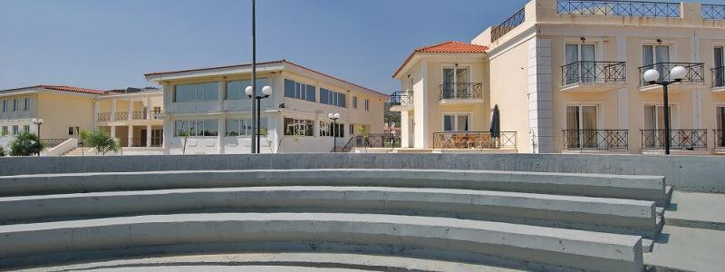](http://www.google.gr/url?sa=i&rct=j&q=&esrc=s&source=images&cd=&cad=rja&uact=8&ved=0ahUKEwjkiufd28HTAhVCuBQKHbV7DP8QjRwIBw&url=http://www.grect.com/el/eyropaikos-organismos-dimosioy-dikaioy/paroysiasi-kai-egkatastaseis&psig=AFQjCNFOpqaMbpAvunDaGziCagdH2H7KSw&ust=1493282169244781)

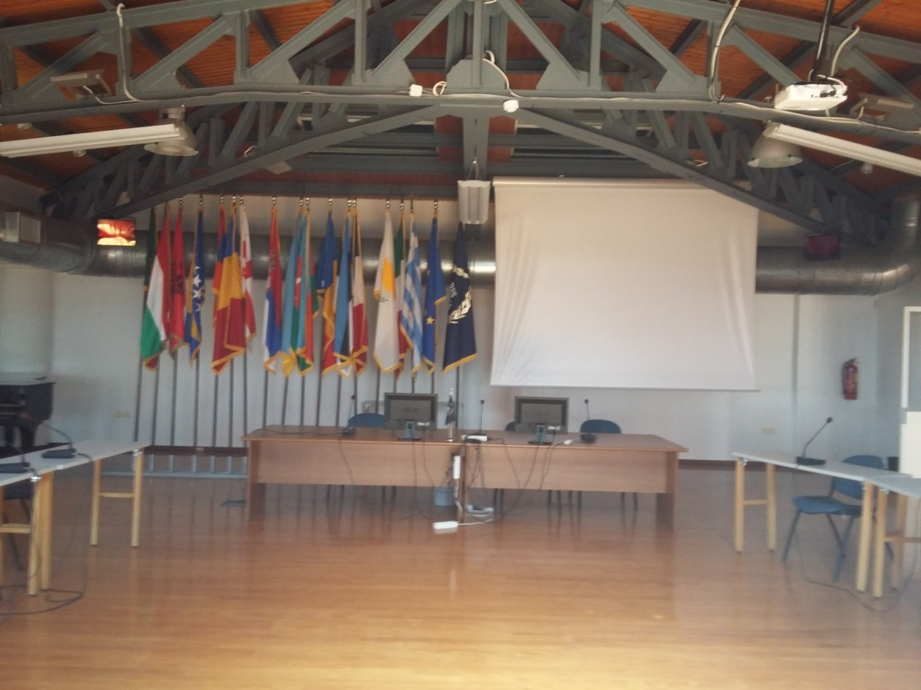

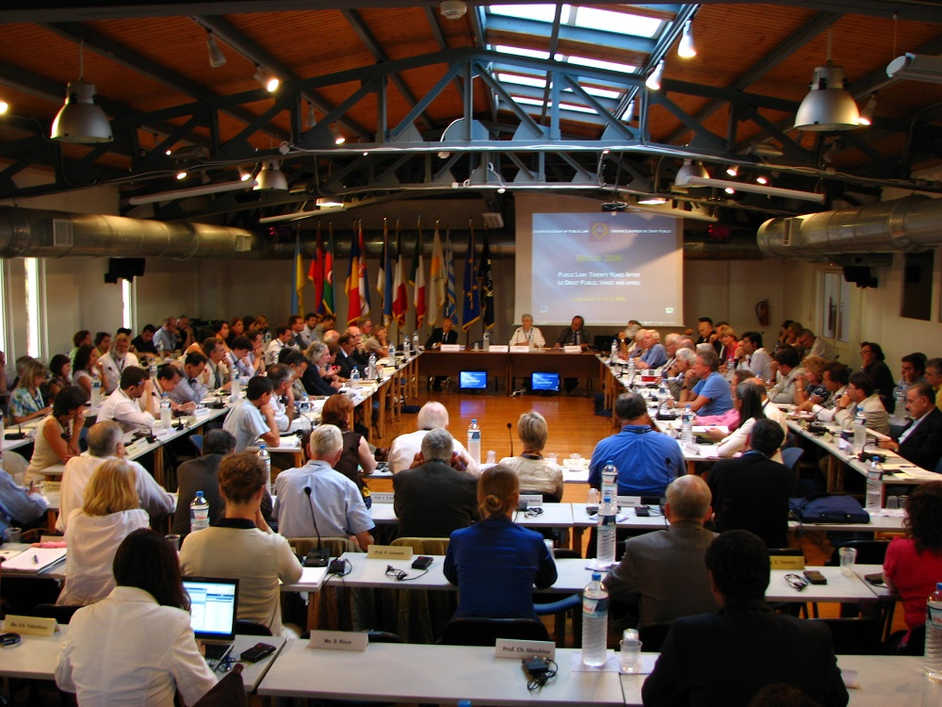

**EPLO, Posidonos, Legrena,**

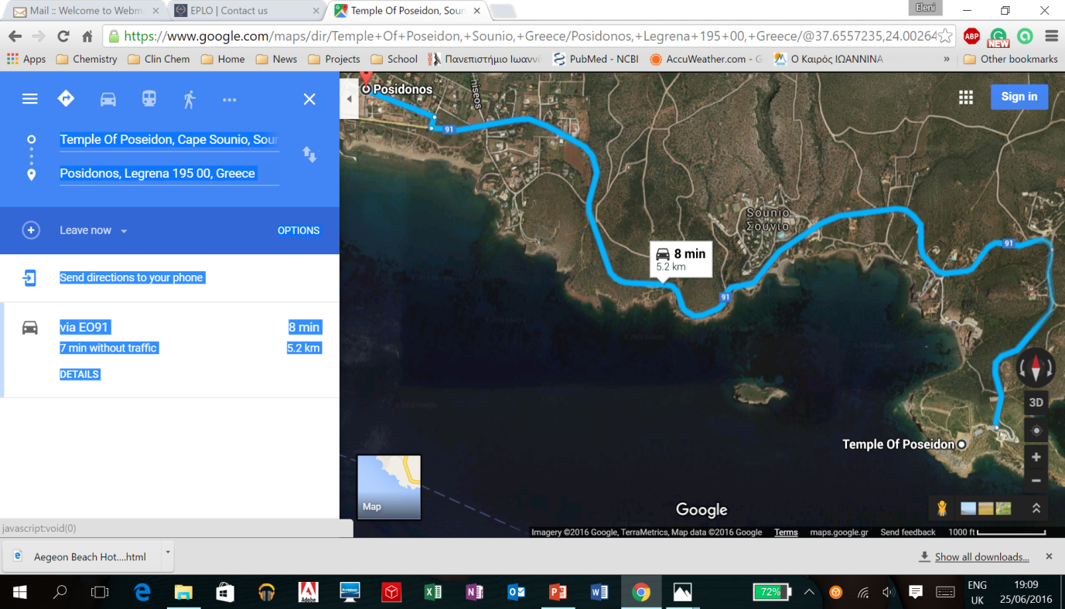

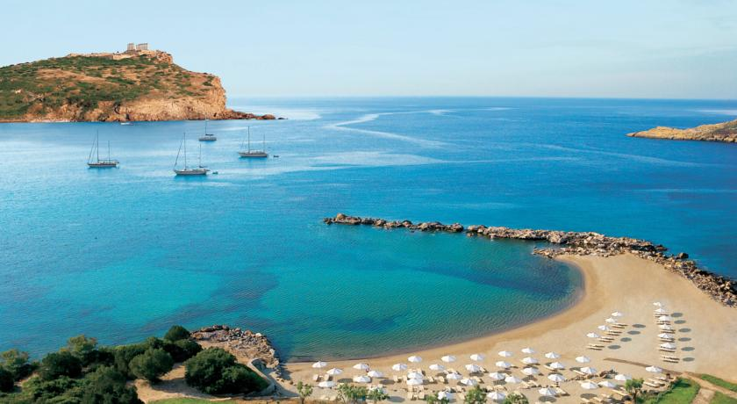

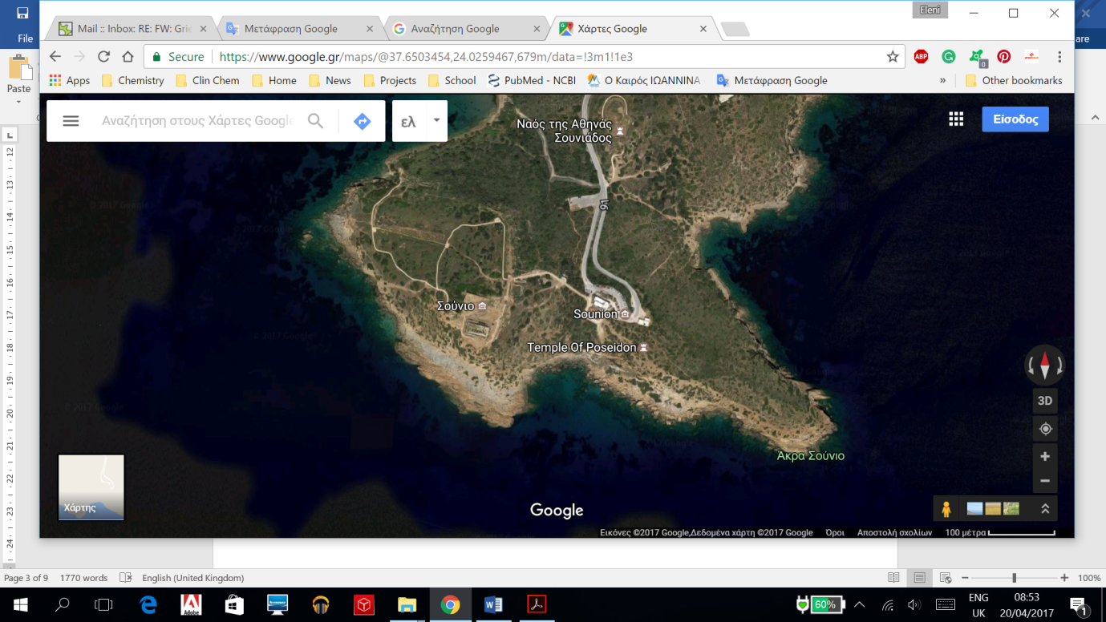

[](https://www.google.gr/url?sa=i&rct=j&q=&esrc=s&source=imgres&cd=&cad=rja&uact=8&ved=0ahUKEwiI8pnasefTAhXIVhoKHc-sAwQQjRwIBw&url=https://www.panoramio.com/user/5740123&psig=AFQjCNHPuKHd7fMG-v9e3u4uFPg9r-3p8w&ust=1494576561121700)

