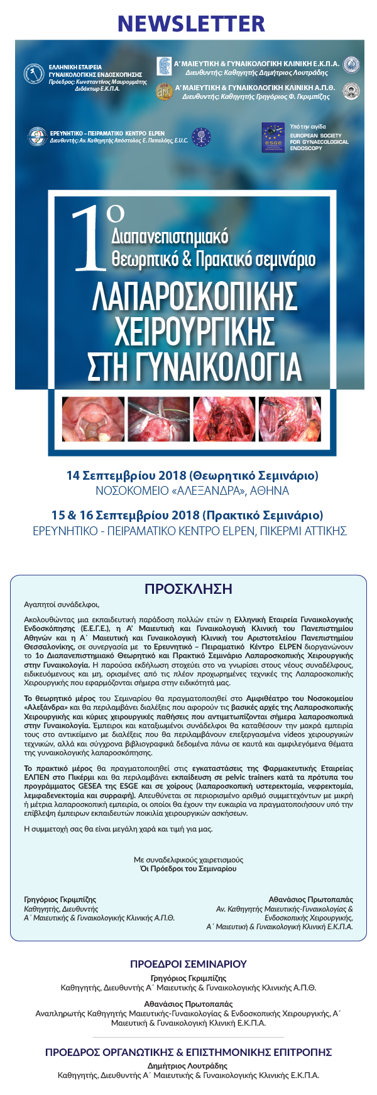

[](https://u7006186.ct.sendgrid.net/wf/click?upn=TX5UzgQbuzA6teklacwILQKQrZO0AqLvtf3qYrIEwaZE53S8mwrmn9Uwx2na1Oqp9vOmsJ7aIoUe0q5P4h7iVw-3D-3D_aszjhi05L32HwbyacBDOcMuFLaSmAfg-2BdM-2F6y8xDisSogwycN9LdUSUQw7S3lPZTPA0X5zeYGq-2FfIJjQGr-2FTBP-2BS-2Fju-2BPWcyGg5fPx60qFA-2BGifAkdrETl1P2NGNY6VOAL8pktHqeJ5-2Fv06Kgem2SQGXyl4dWfjwz4Z0yESRfOOdss9qO0I4FE8rng76DZRTz3ljUqs0XsJiYRp7xjX5uA-3D-3D)

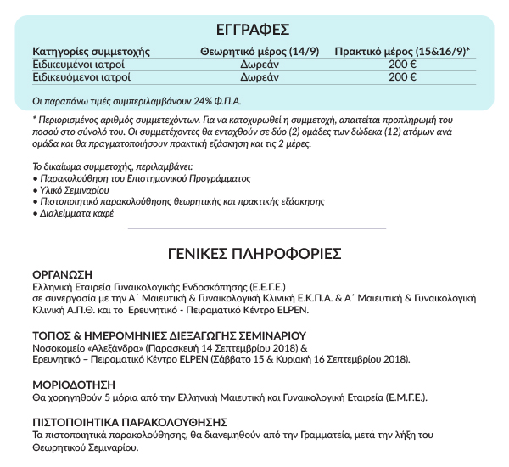

[](https://u7006186.ct.sendgrid.net/wf/click?upn=TX5UzgQbuzA6teklacwILQKQrZO0AqLvtf3qYrIEwaZE53S8mwrmn9Uwx2na1OqpHEyVY-2F5A1VKxCDBn-2FgIk6A-3D-3D_aszjhi05L32HwbyacBDOcMuFLaSmAfg-2BdM-2F6y8xDisSogwycN9LdUSUQw7S3lPZTSJQXWJpXRXtfA2HqPAHCxgzvP5CGEKcM5xSvNz0dmiKjCoIU6UCQf-2BAU8TkskjBzzAnJMFiBRUVyh7lEqr1U6ecHmjD0iLnA0yZwf8lequ-2Fw2RRvQ7nv5nsafD331-2FqEe-2BqHZfasi9PB8MInaAivOw-3D-3D)cid:8852b73b83dd13954b68d805735dfe35@mdcongress.gr

[](https://u7006186.ct.sendgrid.net/wf/click?upn=TX5UzgQbuzA6teklacwILQKQrZO0AqLvtf3qYrIEwaZE53S8mwrmn9Uwx2na1OqplTtPtju6SS6e3coyO5Drlw-3D-3D_aszjhi05L32HwbyacBDOcMuFLaSmAfg-2BdM-2F6y8xDisSogwycN9LdUSUQw7S3lPZTJrIu9-2FLXYqYmPdjLoI5nmWgAba-2B110pbr5PPQYyICl118U-2BsKJYL9WNaZczj3If8eI1DHkcOrR-2FsEnJclWNEWcE9Hkpdr8HWwKN-2FZGC-2FxjNN2NuXKzkJWaSx-2F8-2Fc4FCy6ZzvlUUwjjYf-2BoG0s143Rg-3D-3D)   [](https://u7006186.ct.sendgrid.net/wf/click?upn=TX5UzgQbuzA6teklacwILQKQrZO0AqLvtf3qYrIEwaZE53S8mwrmn9Uwx2na1Oqp5SaHx24Rz2meKRcMMabFOQ-3D-3D_aszjhi05L32HwbyacBDOcMuFLaSmAfg-2BdM-2F6y8xDisSogwycN9LdUSUQw7S3lPZTWFZsY65OsN7h6Ys9BWO11orGj1mJTxXL981FCRgjSLjM8Weno3ziWVFbNCyMbSlctcDO6wqu5hW4M0n6hAW9CUyWvPwF167XJ7ypv93N2pOwqYXER4BUjQ-2BXSSQ7hJA4D8qA6xgfU6138SR5aCEewQ-3D-3D)