

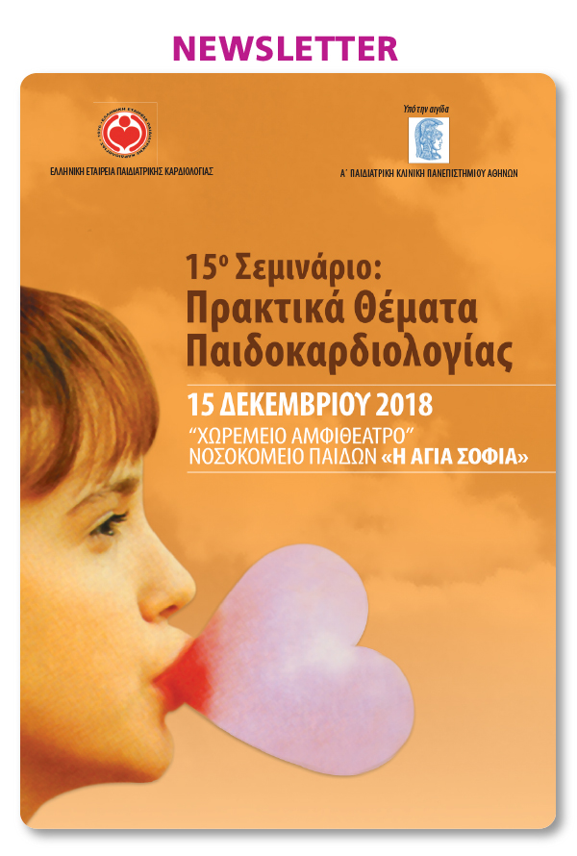

[](https://u7006186.ct.sendgrid.net/wf/click?upn=TX5UzgQbuzA6teklacwILQKQrZO0AqLvtf3qYrIEwaZE53S8mwrmn9Uwx2na1OqpX3tt65E5khosYf-2FtDLLXFA-3D-3D_aszjhi05L32HwbyacBDOcL80ovstcCb83UiYAsQgXJTQaYSr6DuN9lELCujRjoVQ3Nwt0VCwb9frTNzgA0PDPorMChzZixwxfy5F0g8t7W18xipWEBDaWj8Ml-2F4VO6K9ScAbVd83qwp9u-2FSCohF-2BLbzpMLseLAf3g9-2BrGJoOYI5oGtg0jjC7m-2FA4rmoPL7pNUQ8A2rZZaaBZM-2Bq-2BKng7SA-3D-3D)

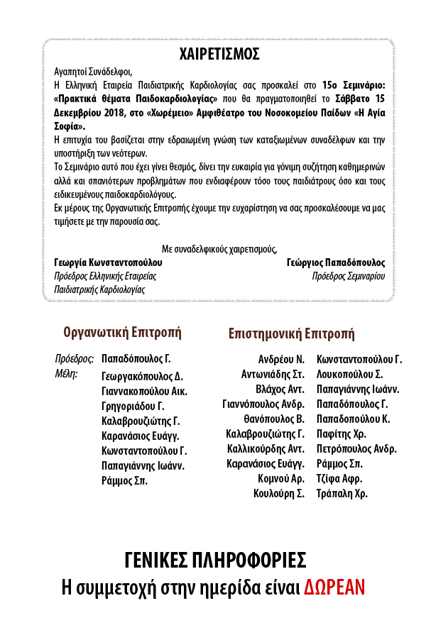

cid:4c6abb807395d999e6f632c3956a9f0f@mdcongress.gr

[](https://u7006186.ct.sendgrid.net/wf/click?upn=TX5UzgQbuzA6teklacwILQKQrZO0AqLvtf3qYrIEwaZE53S8mwrmn9Uwx2na1OqpVcAEsNGvY2kncHQOQ8iwMA-3D-3D_aszjhi05L32HwbyacBDOcL80ovstcCb83UiYAsQgXJTQaYSr6DuN9lELCujRjoVQanyGMjqW82fgazBKuFyoQuKL4exvkCAshHC9m4FThnY-2FTQoG0dcoz71rqXuj5Q5QnRPpEnfAuBzUoPhWdxYW5dtB-2FLWGs5B0BwGMGoC-2FeE0wqcRC9nqBGl4lmrFm4tOsVe1Zq908ejJxF-2FdFeUdzOQ-3D-3D)   [](https://u7006186.ct.sendgrid.net/wf/click?upn=TX5UzgQbuzA6teklacwILQKQrZO0AqLvtf3qYrIEwaZE53S8mwrmn9Uwx2na1OqpiPilGnJ8Z7a-2Bw2g5Z8UsAg-3D-3D_aszjhi05L32HwbyacBDOcL80ovstcCb83UiYAsQgXJTQaYSr6DuN9lELCujRjoVQqbDpq4IFOEepod6FsWvqK9VDTrBcqRcp9Pa-2F-2BiGHg8K7RoCp5dnQsqGJWXrZ3Ua1yHdyKUkFMhQW3dZc7JtyCHaqvbcOZ1n894YO4mI2b0SegqkUADLb6S2wOrFxxdzLgPKwK73daXe5QKGFWMDV7g-3D-3D)