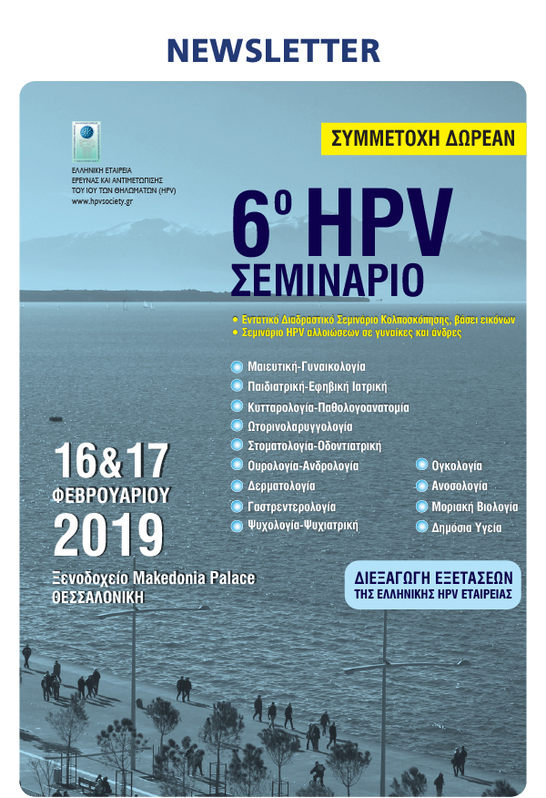

[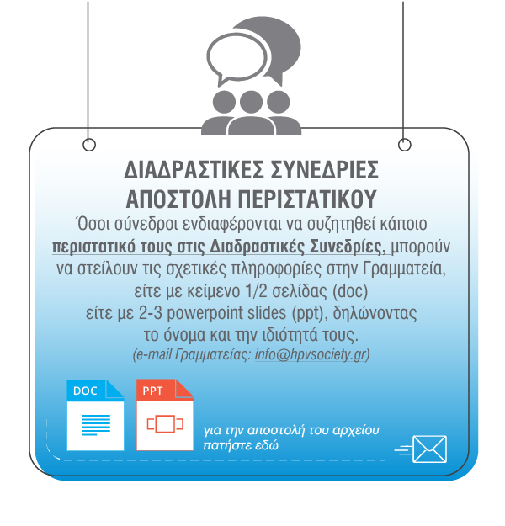](https://u7006186.ct.sendgrid.net/wf/click?upn=TX5UzgQbuzA6teklacwILQKQrZO0AqLvtf3qYrIEwaZE53S8mwrmn9Uwx2na1OqpmXvMBcd8c-2FAhqwFndo5-2FAgOqpGzUwqB4Tuf1h4504wI-3D_aszjhi05L32HwbyacBDOcAIvP60MZ4zUhJqdyuVzgL5Mn-2FdZsrwZfGutKpJXemD3SYk6Q-2FFHvMWslC4vFYyKxtPoTCrbj9wh2BANHoNgayiyg0GH9LrpLkFyHLfX1cJ9xZDUkXNEuzSlPQjXGnXcFZLFQSIiIyG90ySAWf9fWMFawpx-2BP9C9nEjv1laUkzZ3vQB6QVjb1N8xazvWD-2BAeVQ-3D-3D)

[](https://u7006186.ct.sendgrid.net/wf/click?upn=TX5UzgQbuzA6teklacwILQKQrZO0AqLvtf3qYrIEwaZE53S8mwrmn9Uwx2na1OqplPGtBDsLZ5ggocteuiWgfJANo3wf1Hj6nFuxD69Omx8-3D_aszjhi05L32HwbyacBDOcAIvP60MZ4zUhJqdyuVzgL5Mn-2FdZsrwZfGutKpJXemD3tOUHe6RheEjYhwyr5in-2FWZ6iwqRimUEcjvQKzT6PC7tb7cVNlyVglfl2CFv83AZ-2BWbPTPkNACVpc-2F0-2BFEjWHPIVnQ86Y0NqIu-2F7vdoeMaQVxz9BT9T-2Fg2DMdc3E83dI0XHruHMqSYvl8mPRDEMyU-2BQ-3D-3D)

cid:7d4e84205d4a1057224313196d27c1ef@mdcongress.gr

[](https://u7006186.ct.sendgrid.net/wf/click?upn=TX5UzgQbuzA6teklacwILQKQrZO0AqLvtf3qYrIEwaZE53S8mwrmn9Uwx2na1OqpLKgZp0Px8Z8Z92NQZxebFA-3D-3D_aszjhi05L32HwbyacBDOcAIvP60MZ4zUhJqdyuVzgL5Mn-2FdZsrwZfGutKpJXemD3-2FQlMadKlzEEpQYDd4PyFuXXk6meP5BfEL5YwpQXX8wGYlFOPIqBLeklCmyWfE9jpAHC4tJHZTqPmJoMOpi-2FD56VQwbB6NF2HJc-2FcOxX9U1r4Eg5-2BxaDKEyzqlpWeGi1jzD-2Bost5dAY3s3dwVSV7VUA-3D-3D)   [](https://u7006186.ct.sendgrid.net/wf/click?upn=TX5UzgQbuzA6teklacwILQKQrZO0AqLvtf3qYrIEwaZE53S8mwrmn9Uwx2na1OqpotFSmS8I5op9KF5kRsAqwA-3D-3D_aszjhi05L32HwbyacBDOcAIvP60MZ4zUhJqdyuVzgL5Mn-2FdZsrwZfGutKpJXemD34ZeVCjUALrZ26yNkiqiTFYJSjFwfEpEwYR7lcIoUZABAXCH0ROvmZkOk-2FdgpnkIymFRRVVHjTv-2FIIl0kvyEEVdTVWy-2FlUdhUy-2FAxhvi2Wp-2Fgk1zPKvIcN-2F6VM0Fx9UEbHoJvcbiVTUiCQ2VTA1eSKA-3D-3D)

Μην απαντήσετε σε αυτό το μήνυμα.  
Σε περίπτωση που **δεν επιθυμείτε να λαμβάνετε newsletter της εταιρείας μας** πατήστε [ΔΙΑΓΡΑΦΗ](https://u7006186.ct.sendgrid.net/wf/click?upn=TX5UzgQbuzA6teklacwILQKQrZO0AqLvtf3qYrIEwaZFIgZtr1OWscTVITfymp59qwcTbMmT68bTSiNRbOARsuk-2Bn4vRRAvbt5SNcEV9wTVMi9-2FFxaS4KslPdyr1d7oVh7jiOTqaFyKVxz0aOOueqA-3D-3D_aszjhi05L32HwbyacBDOcAIvP60MZ4zUhJqdyuVzgL5Mn-2FdZsrwZfGutKpJXemD3kHszgup4Wa9aqVWFyMKn6LHEfKxZb8iIMZPB0D2jDvGszCpCxPCh2cFdrKCdX-2B39wVF2UH00A1Z5cG7EXQZN7v60RBVoDSu-2FeR-2Fe0vumBPvybePIcKuaCIAEM6eHSF1c5MWpEkb5rEDpRkT8YjmZYg-3D-3D)

Don't answer to this e-mail.  
If you wish to unsubscribe **from receiving future e-mail messages** please [CLICK HERE](https://u7006186.ct.sendgrid.net/wf/click?upn=TX5UzgQbuzA6teklacwILQKQrZO0AqLvtf3qYrIEwaZFIgZtr1OWscTVITfymp59qwcTbMmT68bTSiNRbOARsuk-2Bn4vRRAvbt5SNcEV9wTVMi9-2FFxaS4KslPdyr1d7oVh7jiOTqaFyKVxz0aOOueqA-3D-3D_aszjhi05L32HwbyacBDOcAIvP60MZ4zUhJqdyuVzgL5Mn-2FdZsrwZfGutKpJXemD30rxdzB-2B9vtM9SQeboJzeStdK67UqtUbqr8Yo9ip69DLM90oTe9b3woYakWUV5K-2BrPFaSQ7UGJS86rKJc6h0-2Bed2qWsHxwu-2BwGcqzuGeU1i8IBiw2Uaf8ZGqYN86fryUI8cfxQd-2B-2BDzixbKq02-2B5gmA-3D-3D)