[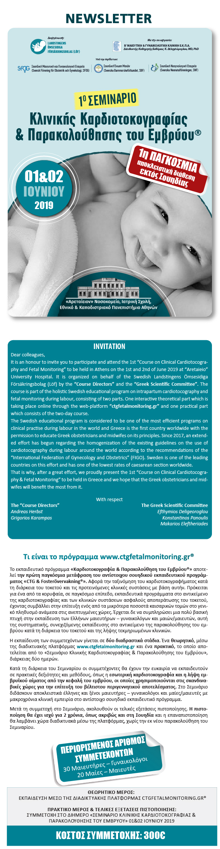](https://u7006186.ct.sendgrid.net/wf/click?upn=TX5UzgQbuzA6teklacwILQKQrZO0AqLvtf3qYrIEwaZE53S8mwrmn9Uwx2na1OqpGbmu4hxwGWSMH68irDXbNXw-2Bl0LQfeBYwolSG7Ns4wc-3D_aszjhi05L32HwbyacBDOcFtS7m6DNQLEVDMpx8g8Y33gdYGgxBWO41gPKdIUWewGo-2B0VR6xLG8nugpeyesImGV9M8Zpr66w4SZHA8FCQeR0oMUHqsi3cYuGUJCIYCqr5haFdyEsVMdt5j4n3UAP9ikd1F-2BNkS6BEY-2BAtxaa9A5GQcQh8kaXTK0hcmNDOTyJyn0FAYSnZWK4Tka7-2BoU7kqg-3D-3D)

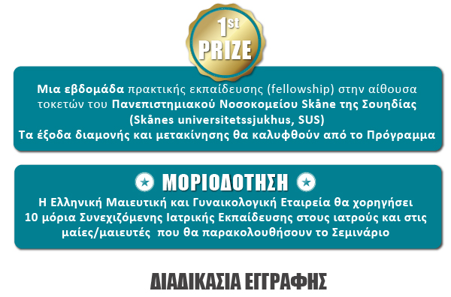

[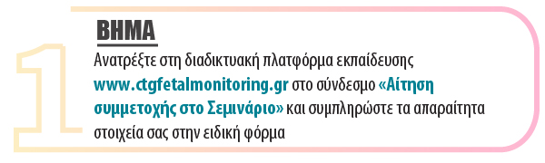](https://u7006186.ct.sendgrid.net/wf/click?upn=TX5UzgQbuzA6teklacwILQKQrZO0AqLvtf3qYrIEwaZE53S8mwrmn9Uwx2na1Oqpy0oZRK-2FXPS8BiiPUFNbXLTy5L2yR2ovCd2b4Go-2BJvrE-3D_aszjhi05L32HwbyacBDOcFtS7m6DNQLEVDMpx8g8Y33gdYGgxBWO41gPKdIUWewGu-2FwZA7-2BFTYH2kwnrdW-2FHzB-2FKWydnLaR9tvP97KDE4h-2F4gyLhgrNkbhjWkUV16xhMdLFNy4M2kgbimuGZbnOOj1zfn77gMeK7xdpuTgjwovhAK-2BA4FMVdeV4Z5Sx1R5FXJ-2B2vscq2DAisTVuZj0kiNw-3D-3D)

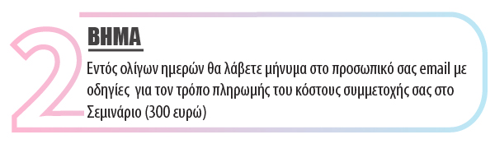

[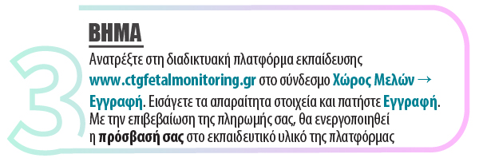](https://u7006186.ct.sendgrid.net/wf/click?upn=TX5UzgQbuzA6teklacwILQKQrZO0AqLvtf3qYrIEwaZE53S8mwrmn9Uwx2na1OqpyJzWg6ed5AOgJGsJeBGZcL-2BbRmkqg0NiQ91CIyeClIY-3D_aszjhi05L32HwbyacBDOcFtS7m6DNQLEVDMpx8g8Y33gdYGgxBWO41gPKdIUWewGOfdPUOTNTcWzCXvqNrPr8HvwZtsc-2BjbRc5RIf4M5S1qe8X1anyKy-2BZXRAdUIah2d2D8XaY-2BcLxImvjBP1WESD9iwfplXMx9N6t04-2Fp2xfLV5aUuZ8a1WKtz7xdDOKTyaWqfP10J8OOgc5MsChpkTcA-3D-3D)

[](https://u7006186.ct.sendgrid.net/wf/click?upn=TX5UzgQbuzA6teklacwILQKQrZO0AqLvtf3qYrIEwaZE53S8mwrmn9Uwx2na1OqpGbmu4hxwGWSMH68irDXbNXw-2Bl0LQfeBYwolSG7Ns4wc-3D_aszjhi05L32HwbyacBDOcFtS7m6DNQLEVDMpx8g8Y33gdYGgxBWO41gPKdIUWewGrx84UgYiLEhQHiClcksBlLcc06Q-2B49BknURmk-2F4DkYk-2FZvKnWKqgq3O0UJwA4krMFA-2FV7pOZjZfRRFSHLDoPbBXZa3ycW-2BmrWwLra0b-2BcERjlmM7-2FOz9G2DNliqbqjpX4agf0Uks-2BaBxzmyx7lrM7Q-3D-3D)



[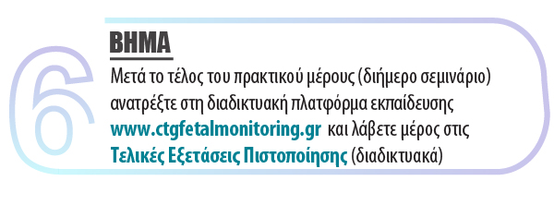](https://u7006186.ct.sendgrid.net/wf/click?upn=TX5UzgQbuzA6teklacwILQKQrZO0AqLvtf3qYrIEwaZE53S8mwrmn9Uwx2na1Oqpb-2Bm-2BNCWt2BpFfFnt0gYFzkQW7MaEruhg4tGXroOw7VY-3D_aszjhi05L32HwbyacBDOcFtS7m6DNQLEVDMpx8g8Y33gdYGgxBWO41gPKdIUWewGUYo0u-2FQG9hKQ2fZXfJuXsV-2FbGI-2Fxqzx4eZY-2Fxr0jukYMEbKaa3VMer063yY4mqNHFq8wzP9Sc1Ars7zY6RsA3UyaCyMJi-2F8Mzpei56ryU9GQiWQEx-2FkiUZVJsnHjbu4lotcDhvNHh7rYkAcUG40o8Q-3D-3D)

[](https://u7006186.ct.sendgrid.net/wf/click?upn=TX5UzgQbuzA6teklacwILQKQrZO0AqLvtf3qYrIEwaZE53S8mwrmn9Uwx2na1OqpyJzWg6ed5AOgJGsJeBGZcL-2BbRmkqg0NiQ91CIyeClIY-3D_aszjhi05L32HwbyacBDOcFtS7m6DNQLEVDMpx8g8Y33gdYGgxBWO41gPKdIUWewGKYyIUsfSknH0zJRcc5G-2BqNZHow5YlTSo50JTjub6Xvhs40Uk6KOUEBZq7qLQlkH79-2BDixf4kzWbcKINxmUFS8wVDlqaPlbrL6U7P9RO6b5bKvWsW7EJmBuSx14tJgJspADSt2ymiF0G1hGYGya1T0A-3D-3D)

cid:9e34f5d54c5e338ef7519e123eafbdbf@mdcongress.gr